Practica 1

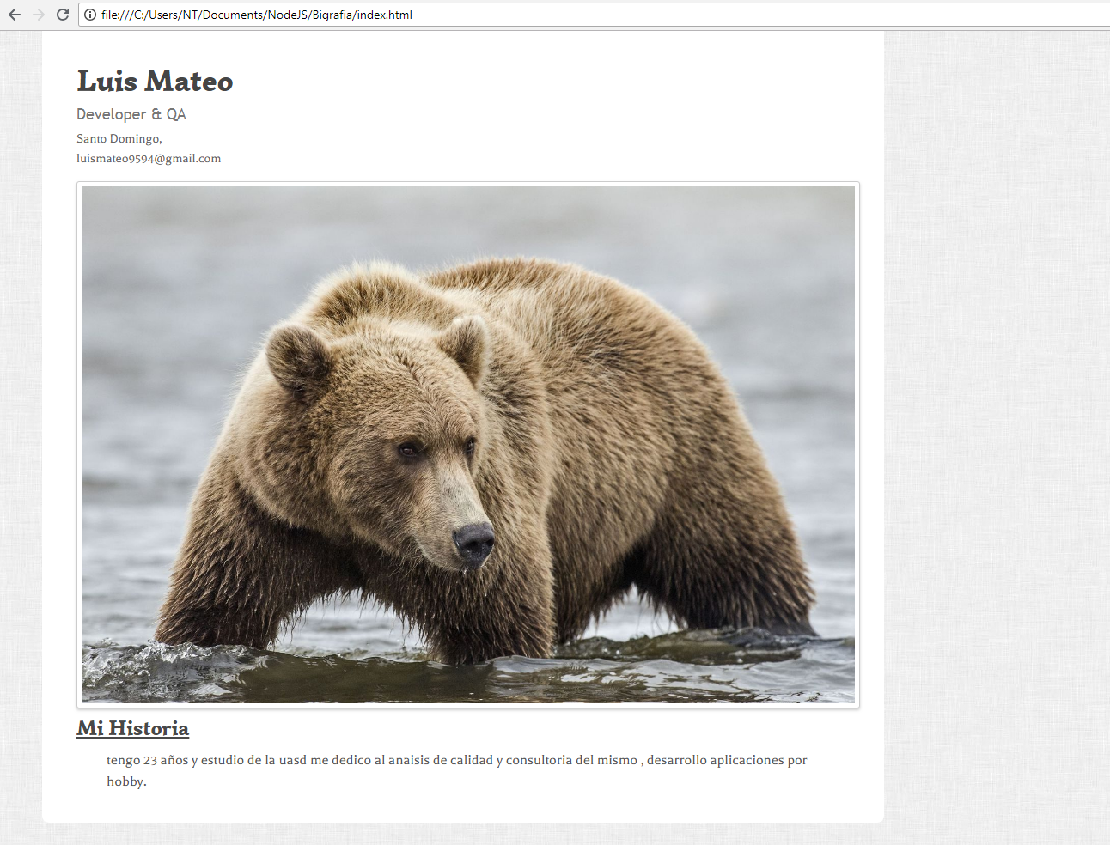

<!doctype html>

<html lang="en">

<head>

<meta http-equiv="Content-Type" content="text/html; charset=utf-8" />

<title>Biografia</title>

<meta name="author" content="Jake Rocheleau">

<meta http-equiv="X-UA-Compatible" content="IE=edge,chrome=1">

<meta name="HandheldFriendly" content="true">

<meta name="viewport" content="width=device-width, initial-scale=1,maximum-scale=1,user-scalable=no">

<link rel="stylesheet" type="text/css" href="http://fonts.googleapis.com/css?family=Simonetta:400,900|Balthazar">

<link rel="stylesheet" type="text/css" href="styles.css">

<link rel="stylesheet" type="text/css" href="responsive.css">

<!--[if lt IE 9]>

<script src="http://html5shim.googlecode.com/svn/trunk/html5.js"></script>

<script src="http://css3-mediaqueries-js.googlecode.com/svn/trunk/css3-mediaqueries.js"></script>

<![endif]-->

</head>

<body>

    <div id="w" itemscope itemtype="http://schema.org/Person">

        <header class="clearfix">

            <div id="info">

                <h1><span itemprop="name">Luis Mateo</span></h1>

                <h3><span itemprop="jobTitle">Developer &amp; QA</span></h3>

                <small itemprop="address" itemscope itemtype="http://schema.org/PostalAddress">

                 <span itemprop="addressLocality">Santo Domingo</span>,

                </small>

                <small><span itemprop="email">luismateo9594@gmail.com</span></small>

            </div>

            <div id="photo">

                <img src="https://www.ososwiki.com/Imagenes/foto-hd-de-osos.jpg" alt="Jake Rocheleau resume photo avatar" itemprop="image" />

            </div>

        </header>

        <section id="profile">

            <h2>Mi Historia</h2>

            <p itemprop="description">tengo 23 años y estudio de la uasd me dedico al anaisis de calidad y consultoria del mismo , desarrollo aplicaciones por hobby. </p>

        </section>

    </div>

</body>

</html>

Practica 2

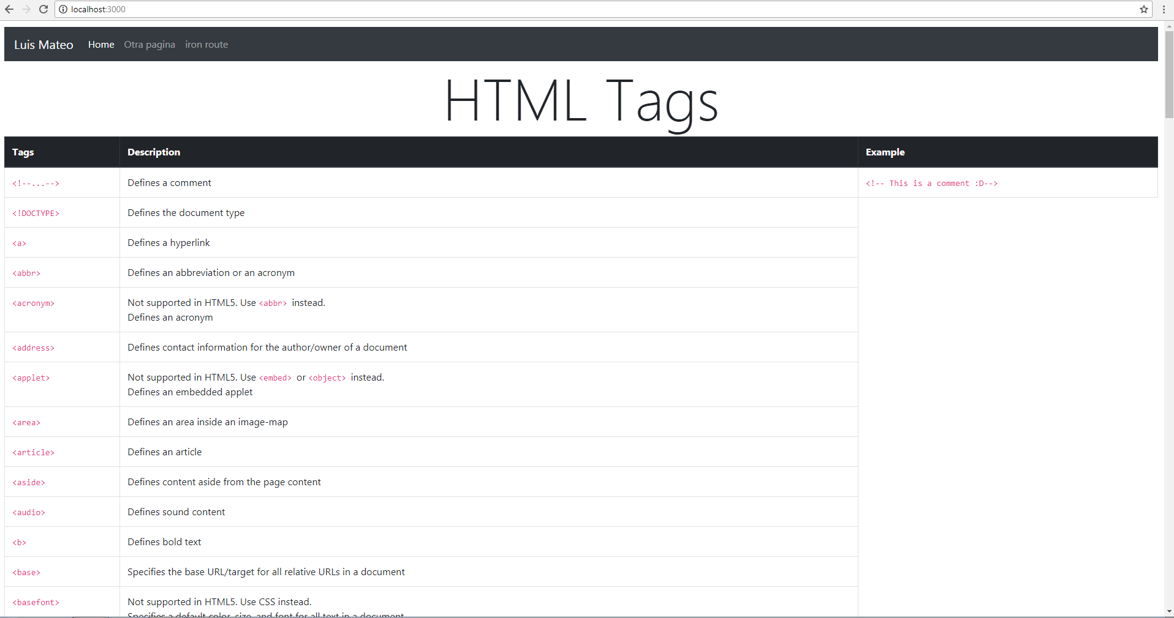

<head>

<title>HTML Tags</title>

<link rel="stylesheet" href="https://stackpath.bootstrapcdn.com/bootstrap/4.1.3/css/bootstrap.min.css" integrity="sha384-MCw98/SFnGE8fJT3GXwEOngsV7Zt27NXFoaoApmYm81iuXoPkFOJwJ8ERdknLPMO" crossorigin="anonymous">

</head>

<body>

{{> navbarTem}}

<h1 class="display-1" style="justify-content:center;display:flex;"> HTML Tags</h1>

</body>

<template name="tags">

<div class="table-responsive">

<table class="table table-bordered">

<thead class="thead-dark">

<tr>

<th scope="col" style="width:10%">Tags</th>

<th scope="col">Description</th>

<th scope="col">Example</th>

</tr>

</thead>

<tr>

<td> <code><a class ="tagStyle" id=" tag_comment.asp">&lt;!--...--&gt; </a></code></td>

<td>Defines a comment</td>

<td><code>&lt;!-- This is a comment :D--&gt;</code></td>

</tr>

<tr>

<td> <code><a class ="tagStyle" id=" tag_doctype.asp">&lt;!DOCTYPE&gt; </a></code>&nbsp;</td>

<td>Defines the document type</td>

</tr>

<tr>

<td> <code><a class ="tagStyle" id=" tag_a.asp">&lt;a&gt; </a></code></td>

<td>Defines a hyperlink</td>

</tr>

<tr>

<td> <code><a class ="tagStyle" id=" tag_abbr.asp">&lt;abbr&gt; </a></code></td>

<td>Defines an abbreviation or an acronym</td>

</tr>

<tr>

<td> <code><a class ="tagStyle" id=" tag_acronym.asp" >&lt;acronym&gt; </a></code></td>

<td><span class="deprecated">Not supported in HTML5. Use <code><a class ="tagStyle" id=" tag_abbr.asp">&lt;abbr&gt; </a></code> instead.<br></span>Defines an acronym</td>

</tr>

<tr>

<td> <code><a class ="tagStyle" id=" tag_address.asp">&lt;address&gt; </a></code></td>

<td>Defines contact information for the author/owner of a document</td>

</tr>

<tr>

<td> <code><a class ="tagStyle" id=" tag_applet.asp" >&lt;applet&gt; </a></code></td>

<td><span class="deprecated">Not supported in HTML5. Use <code><a class ="tagStyle" id=" tag_embed.asp">&lt;embed&gt; </a></code> or <code><a class ="tagStyle" id=" tag_object.asp">&lt;object&gt; </a></code> instead.<br></span>Defines an embedded applet</td>

</tr>

<tr>

<td> <code><a class ="tagStyle" id=" tag_area.asp">&lt;area&gt; </a></code></td>

<td>Defines an area inside an image-map</td>

</tr>

<tr>

<td class="html5badge"> <code><a class ="tagStyle" id=" tag_article.asp">&lt;article&gt; </a></code></td>

<td>Defines an article</td>

</tr>

<tr>

<td class="html5badge"> <code><a class ="tagStyle" id=" tag_aside.asp">&lt;aside&gt; </a></code></td>

<td>Defines content aside from the page content</td>

</tr>

<tr>

<td class="html5badge"> <code><a class ="tagStyle" id=" tag_audio.asp">&lt;audio&gt; </a></code></td>

<td>Defines sound content</td>

</tr>

<tr>

<td> <code><a class ="tagStyle" id=" tag_b.asp">&lt;b&gt; </a></code></td>

<td>Defines bold text</td>

</tr>

<tr>

<td> <code><a class ="tagStyle" id=" tag_base.asp">&lt;base&gt; </a></code></td>

<td>Specifies the base URL/target for all relative URLs in a document</td>

</tr>

<tr>

<td> <code><a class ="tagStyle" id=" tag_basefont.asp" >&lt;basefont&gt; </a></code></td>

<td><span class="deprecated">Not supported in HTML5. Use CSS instead.<br></span>Specifies a default color, size, and font for all text in a document</td>

</tr>

<tr>

<td class="html5badge"> <code><a class ="tagStyle" id=" tag_bdi.asp">&lt;bdi&gt; </a></code></td>

<td>Isolates a part of text that might be formatted in a different direction

from other text outside it</td>

</tr>

<tr>

<td> <code><a class ="tagStyle" id=" tag_bdo.asp">&lt;bdo&gt; </a></code></td>

<td>Overrides the current text direction</td>

</tr>

<tr>

<td> <code><a class ="tagStyle" id=" tag_big.asp" >&lt;big&gt; </a></code></td>

<td><span class="deprecated">Not supported in HTML5. Use CSS instead.<br></span>Defines big text</td>

</tr>

<tr>

<td> <code><a class ="tagStyle" id=" tag_blockquote.asp">&lt;blockquote&gt; </a></code></td>

<td>Defines a section that is quoted from another source</td>

</tr>

<tr>

<td> <code><a class ="tagStyle" id=" tag_body.asp">&lt;body&gt; </a></code></td>

<td>Defines the document's body</td>

</tr>

<tr>

<td> <code><a class ="tagStyle" id=" tag_br.asp">&lt;br&gt; </a></code></td>

<td>Defines a single line break</td>

</tr>

<tr>

<td> <code><a class ="tagStyle" id=" tag_button.asp">&lt;button&gt; </a></code></td>

<td>Defines a clickable button</td>

</tr>

<tr>

<td class="html5badge"> <code><a class ="tagStyle" id=" tag_canvas.asp">&lt;canvas&gt; </a></code></td>

<td>Used to draw graphics, on the fly, via scripting (usually JavaScript)</td>

</tr>

<tr>

<td> <code><a class ="tagStyle" id=" tag_caption.asp">&lt;caption&gt; </a></code></td>

<td>Defines a table caption</td>

</tr>

<tr>

<td> <code><a class ="tagStyle" id=" tag_center.asp" >&lt;center&gt; </a></code></td>

<td><span class="deprecated">Not supported in HTML5. Use CSS instead.<br></span>Defines centered text</td>

</tr>

<tr>

<td> <code><a class ="tagStyle" id=" tag_cite.asp">&lt;cite&gt; </a></code></td>

<td>Defines the title of a work</td>

</tr>

<tr>

<td> <code><a class ="tagStyle" id=" tag_code.asp">&lt;code&gt; </a></code></td>

<td>Defines a piece of computer code</td>

</tr>

<tr>

<td> <code><a class ="tagStyle" id=" tag_col.asp">&lt;col&gt; </a></code></td>

<td>Specifies column properties for each column within a &lt;colgroup&gt; element&nbsp;</td>

</tr>

<tr>

<td> <code><a class ="tagStyle" id=" tag_colgroup.asp">&lt;colgroup&gt; </a></code></td>

<td>Specifies a group of one or more columns in a table for formatting</td>

</tr>

<tr>

<td class="html5badge"> <code><a class ="tagStyle" id=" tag_data.asp">&lt;data&gt; </a></code></td>

<td>Links the given content with a machine-readable translation</td>

</tr>

<tr>

<td class="html5badge"> <code><a class ="tagStyle" id=" tag_datalist.asp">&lt;datalist&gt; </a></code></td>

<td>Specifies a list of pre-defined options for input controls</td>

</tr>

<tr>

<td> <code><a class ="tagStyle" id=" tag_dd.asp">&lt;dd&gt; </a></code></td>

<td>Defines a description/value of a term in a description list</td>

</tr>

<tr>

<td> <code><a class ="tagStyle" id=" tag_del.asp">&lt;del&gt; </a></code></td>

<td>Defines text that has been deleted from a document</td>

</tr>

<tr>

<td class="html5badge"> <code><a class ="tagStyle" id=" tag_details.asp">&lt;details&gt; </a></code></td>

<td>Defines additional details that the user can view or hide</td>

</tr>

<tr>

<td> <code><a class ="tagStyle" id=" tag_dfn.asp">&lt;dfn&gt; </a></code></td>

<td>Represents the defining instance of a term</td>

</tr>

<tr>

<td class="html5badge"> <code><a class ="tagStyle" id=" tag_dialog.asp">&lt;dialog&gt; </a></code></td>

<td>Defines a dialog box or window</td>

</tr>

<tr>

<td> <code><a class ="tagStyle" id=" tag_dir.asp" >&lt;dir&gt; </a></code></td>

<td><span class="deprecated">Not supported in HTML5. Use <code><a class ="tagStyle" id=" tag_ul.asp">&lt;ul&gt; </a></code> instead.<br></span>Defines a directory list</td>

</tr>

<tr>

<td> <code><a class ="tagStyle" id=" tag_div.asp">&lt;div&gt; </a></code></td>

<td>Defines a section in a document</td>

</tr>

<tr>

<td> <code><a class ="tagStyle" id=" tag_dl.asp">&lt;dl&gt; </a></code></td>

<td>Defines a description list</td>

</tr>

<tr>

<td> <code><a class ="tagStyle" id=" tag_dt.asp">&lt;dt&gt; </a></code></td>

<td>Defines a term/name in a description list</td>

</tr>

<tr>

<td> <code><a class ="tagStyle" id=" tag_em.asp">&lt;em&gt; </a></code></td>

<td>Defines emphasized text&nbsp;</td>

</tr>

<tr>

<td class="html5badge"> <code><a class ="tagStyle" id=" tag_embed.asp">&lt;embed&gt; </a></code></td>

<td>Defines a container for an external (non-HTML) application</td>

</tr>

<tr>

<td> <code><a class ="tagStyle" id=" tag_fieldset.asp">&lt;fieldset&gt; </a></code></td>

<td>Groups related elements in a form</td>

</tr>

<tr>

<td class="html5badge"> <code><a class ="tagStyle" id=" tag_figcaption.asp">&lt;figcaption&gt; </a></code></td>

<td>Defines a caption for a &lt;figure&gt; element</td>

</tr>

<tr>

<td class="html5badge"> <code><a class ="tagStyle" id=" tag_figure.asp">&lt;figure&gt; </a></code></td>

<td>Specifies self-contained content</td>

</tr>

<tr>

<td> <code><a class ="tagStyle" id=" tag_font.asp" >&lt;font&gt; </a></code></td>

<td><span class="deprecated">Not supported in HTML5. Use CSS instead.<br></span>Defines font, color, and size for text</td>

</tr>

<tr>

<td class="html5badge"> <code><a class ="tagStyle" id=" tag_footer.asp">&lt;footer&gt; </a></code></td>

<td>Defines a footer for a document or section</td>

</tr>

<tr>

<td> <code><a class ="tagStyle" id=" tag_form.asp">&lt;form&gt; </a></code></td>

<td>Defines an HTML form for user input</td>

</tr>

<tr>

<td> <code><a class ="tagStyle" id=" tag_frame.asp" >&lt;frame&gt; </a></code></td>

<td><span class="deprecated">Not supported in HTML5.<br></span>Defines a window (a frame) in a frameset</td>

</tr>

<tr>

<td> <code><a class ="tagStyle" id=" tag_frameset.asp" >&lt;frameset&gt; </a></code></td>

<td><span class="deprecated">Not supported in HTML5.<br></span>Defines a set of frames</td>

</tr>

<tr>

<td> <code><a class ="tagStyle" id=" tag_hn.asp">&lt;h1&gt; to &lt;h6&gt; </a></code></td>

<td> Defines HTML headings</td>

</tr>

<tr>

<td> <code><a class ="tagStyle" id=" tag_head.asp">&lt;head&gt; </a></code></td>

<td>Defines information about the document</td>

<td><code>&lt;head>&lt;title&gt;PageTitle&lt;/title&gt;&lt;/head&gt;</code></td>

</tr>

<tr>

<td class="html5badge"> <code><a class ="tagStyle" id=" tag_header.asp">&lt;header&gt; </a></code></td>

<td>Defines a header for a document or section</td>

</tr>

<tr>

<td> <code><a class ="tagStyle" id=" tag_hr.asp">&lt;hr&gt; </a></code></td>

<td> Defines a thematic change in the content</td>

</tr>

<tr>

<td> <code><a class ="tagStyle" id=" tag_html.asp">&lt;html&gt; </a></code></td>

<td>Defines the root of an HTML document</td>

</tr>

<tr>

<td> <code><a class ="tagStyle" id=" tag_i.asp">&lt;i&gt; </a></code></td>

<td>Defines a part of text in an alternate voice or mood</td>

</tr>

<tr>

<td> <code><a class ="tagStyle" id=" tag_iframe.asp">&lt;iframe&gt; </a></code></td>

<td>Defines an inline frame</td>

</tr>

<tr>

<td> <code><a class ="tagStyle" id=" tag_img.asp">&lt;img&gt; </a></code></td>

<td>Defines an image</td>

</tr>

<tr>

<td> <code><a class ="tagStyle" id=" tag_input.asp">&lt;input&gt; </a></code></td>

<td>Defines an input control</td>

</tr>

<tr>

<td> <code><a class ="tagStyle" id=" tag_ins.asp">&lt;ins&gt; </a></code></td>

<td>Defines a text that has been inserted into a document</td>

</tr>

<tr>

<td> <code><a class ="tagStyle" id=" tag_kbd.asp">&lt;kbd&gt; </a></code></td>

<td>Defines keyboard input</td>

</tr>

<tr>

<td> <code><a class ="tagStyle" id=" tag_label.asp">&lt;label&gt; </a></code></td>

<td>Defines a label&nbsp;for an &lt;input&gt; element</td>

</tr>

<tr>

<td> <code><a class ="tagStyle" id=" tag_legend.asp">&lt;legend&gt; </a></code></td>

<td>Defines a caption for a &lt;fieldset&gt; element</td>

</tr>

<tr>

<td> <code><a class ="tagStyle" id=" tag_li.asp">&lt;li&gt; </a></code></td>

<td>Defines a list item</td>

</tr>

<tr>

<td> <code><a class ="tagStyle" id=" tag_link.asp">&lt;link&gt; </a></code></td>

<td>Defines the relationship between a document and an external resource (most

used to link to style sheets)</td>

</tr>

<tr>

<td class="html5badge"> <code><a class ="tagStyle" id=" tag_main.asp">&lt;main&gt; </a></code></td>

<td>Specifies the main content of a document</td>

</tr>

<tr>

<td> <code><a class ="tagStyle" id=" tag_map.asp">&lt;map&gt; </a></code></td>

<td>Defines a client-side image-map</td>

</tr>

<tr>

<td class="html5badge"> <code><a class ="tagStyle" id=" tag_mark.asp">&lt;mark&gt; </a></code></td>

<td>Defines marked/highlighted text</td>

</tr>

<tr>

<td> <code><a class ="tagStyle" id=" tag_meta.asp">&lt;meta&gt; </a></code></td>

<td>Defines metadata about an HTML document</td>

</tr>

<tr>

<td class="html5badge"> <code><a class ="tagStyle" id=" tag_meter.asp">&lt;meter&gt; </a></code></td>

<td>Defines a scalar measurement within a known range (a gauge)</td>

</tr>

<tr>

<td class="html5badge"> <code><a class ="tagStyle" id=" tag_nav.asp">&lt;nav&gt; </a></code></td>

<td>Defines navigation links</td>

</tr>

<tr>

<td> <code><a class ="tagStyle" id=" tag_noframes.asp" >&lt;noframes&gt; </a></code></td>

<td><span class="deprecated">Not supported in HTML5.<br></span>Defines an alternate content for users that do not support frames</td>

</tr>

<tr>

<td> <code><a class ="tagStyle" id=" tag_noscript.asp">&lt;noscript&gt; </a></code></td>

<td>Defines an alternate content for users that do not support

client-side scripts</td>

</tr>

<tr>

<td> <code><a class ="tagStyle" id=" tag_object.asp">&lt;object&gt; </a></code></td>

<td>Defines an embedded object</td>

</tr>

<tr>

<td> <code><a class ="tagStyle" id=" tag_ol.asp">&lt;ol&gt; </a></code></td>

<td>Defines an ordered list</td>

</tr>

<tr>

<td> <code><a class ="tagStyle" id=" tag_optgroup.asp">&lt;optgroup&gt; </a></code></td>

<td>Defines a group of related options in a drop-down list</td>

</tr>

<tr>

<td> <code><a class ="tagStyle" id=" tag_option.asp">&lt;option&gt; </a></code></td>

<td>Defines an option in a drop-down list</td>

</tr>

<tr>

<td class="html5badge"> <code><a class ="tagStyle" id=" tag_output.asp">&lt;output&gt; </a></code></td>

<td>Defines the result of a calculation</td>

</tr>

<tr>

<td> <code><a class ="tagStyle" id=" tag_p.asp">&lt;p&gt; </a></code></td>

<td>Defines a paragraph</td>

</tr>

<tr>

<td> <code><a class ="tagStyle" id=" tag_param.asp">&lt;param&gt; </a></code></td>

<td>Defines a parameter for an object</td>

</tr>

<tr>

<td class="html5badge"> <code><a class ="tagStyle" id=" tag_picture.asp">&lt;picture&gt; </a></code></td>

<td>Defines a container for multiple image resources</td>

</tr>

<tr>

<td> <code><a class ="tagStyle" id=" tag_pre.asp">&lt;pre&gt; </a></code></td>

<td>Defines preformatted text</td>

</tr>

<tr>

<td class="html5badge"> <code><a class ="tagStyle" id=" tag_progress.asp">&lt;progress&gt; </a></code></td>

<td>Represents the progress of a task</td>

</tr>

<tr>

<td> <code><a class ="tagStyle" id=" tag_q.asp">&lt;q&gt; </a></code></td>

<td>Defines a short quotation</td>

</tr>

<tr>

<td class="html5badge"> <code><a class ="tagStyle" id=" tag_rp.asp">&lt;rp&gt; </a></code></td>

<td>Defines what to show in browsers that do not support ruby annotations</td>

</tr>

<tr>

<td class="html5badge"> <code><a class ="tagStyle" id=" tag_rt.asp">&lt;rt&gt; </a></code></td>

<td>Defines an explanation/pronunciation of characters (for East Asian

typography)</td>

</tr>

<tr>

<td class="html5badge"> <code><a class ="tagStyle" id=" tag_ruby.asp">&lt;ruby&gt; </a></code></td>

<td>Defines a ruby annotation (for East Asian typography)</td>

</tr>

<tr>

<td> <code><a class ="tagStyle" id=" tag_s.asp">&lt;s&gt; </a></code></td>

<td>Defines text that is no longer correct</td>

</tr>

<tr>

<td> <code><a class ="tagStyle" id=" tag_samp.asp">&lt;samp&gt; </a></code></td>

<td>Defines sample output from a computer program</td>

</tr>

<tr>

<td> <code><a class ="tagStyle" id=" tag_script.asp">&lt;script&gt; </a></code></td>

<td>Defines a client-side script</td>

</tr>

<tr>

<td class="html5badge"> <code><a class ="tagStyle" id=" tag_section.asp">&lt;section&gt; </a></code></td>

<td>Defines a section in a document</td>

</tr>

<tr>

<td> <code><a class ="tagStyle" id=" tag_select.asp">&lt;select&gt; </a></code></td>

<td>Defines a drop-down list</td>

</tr>

<tr>

<td> <code><a class ="tagStyle" id=" tag_small.asp">&lt;small&gt; </a></code></td>

<td>Defines smaller text</td>

</tr>

<tr>

<td class="html5badge"> <code><a class ="tagStyle" id=" tag_source.asp">&lt;source&gt; </a></code></td>

<td>Defines multiple media resources for media elements (&lt;video&gt; and &lt;audio&gt;)</td>

</tr>

<tr>

<td> <code><a class ="tagStyle" id=" tag_span.asp">&lt;span&gt; </a></code></td>

<td>Defines a section in a document</td>

</tr>

<tr>

<td> <code><a class ="tagStyle" id=" tag_strike.asp" >&lt;strike&gt; </a></code></td>

<td><span class="deprecated">Not supported in HTML5. Use <code><a class ="tagStyle" id=" tag_del.asp">&lt;del&gt; </a></code> or <code><a class ="tagStyle" id=" tag_s.asp">&lt;s&gt; </a></code> instead.<br></span>Defines strikethrough text</td>

</tr>

<tr>

<td> <code><a class ="tagStyle" id=" tag_strong.asp">&lt;strong&gt; </a></code></td>

<td>Defines important text</td>

</tr>

<tr>

<td> <code><a class ="tagStyle" id=" tag_style.asp">&lt;style&gt; </a></code></td>

<td>Defines style information for a document</td>

</tr>

<tr>

<td> <code><a class ="tagStyle" id=" tag_sub.asp">&lt;sub&gt; </a></code></td>

<td>Defines subscripted text</td>

</tr>

<tr>

<td class="html5badge"> <code><a class ="tagStyle" id=" tag_summary.asp">&lt;summary&gt; </a></code></td>

<td>Defines a visible heading for a &lt;details&gt; element</td>

</tr>

<tr>

<td> <code><a class ="tagStyle" id=" tag_sup.asp">&lt;sup&gt; </a></code></td>

<td>Defines superscripted text</td>

</tr>

<tr>

<td> <code><a class ="tagStyle" id=" tag_svg.asp">&lt;svg&gt; </a></code></td>

<td>Defines a container for SVG graphics</td>

</tr>

<tr>

<td> <code><a class ="tagStyle" id=" tag_table.asp">&lt;table&gt; </a></code></td>

<td>Defines a table</td>

</tr>

<tr>

<td> <code><a class ="tagStyle" id=" tag_tbody.asp">&lt;tbody&gt; </a></code></td>

<td>Groups the body content in a table</td>

</tr>

<tr>

<td> <code><a class ="tagStyle" id=" tag_td.asp">&lt;td&gt; </a></code></td>

<td>Defines a cell in a table</td>

</tr>

<tr>

<td class="html5badge"> <code><a class ="tagStyle" id=" tag_template.asp">&lt;template&gt; </a></code></td>

<td>Defines a template</td>

</tr>

<tr>

<td> <code><a class ="tagStyle" id=" tag_textarea.asp">&lt;textarea&gt; </a></code></td>

<td>Defines a multiline input control (text area)</td>

</tr>

<tr>

<td> <code><a class ="tagStyle" id=" tag_tfoot.asp">&lt;tfoot&gt; </a></code></td>

<td>Groups the footer content in a table</td>

</tr>

<tr>

<td> <code><a class ="tagStyle" id=" tag_th.asp">&lt;th&gt; </a></code></td>

<td>Defines a header cell in a table</td>

</tr>

<tr>

<td> <code><a class ="tagStyle" id=" tag_thead.asp">&lt;thead&gt; </a></code></td>

<td>Groups the header content in a table</td>

</tr>

<tr>

<td class="html5badge"> <code><a class ="tagStyle" id=" tag_time.asp">&lt;time&gt; </a></code></td>

<td>Defines a date/time</td>

</tr>

<tr>

<td> <code><a class ="tagStyle" id=" tag_title.asp">&lt;title&gt; </a></code></td>

<td>Defines a title for the document</td>

</tr>

<tr>

<td> <code><a class ="tagStyle" id=" tag_tr.asp">&lt;tr&gt; </a></code></td>

<td>Defines a row in a table</td>

</tr>

<tr>

<td class="html5badge"> <code><a class ="tagStyle" id=" tag_track.asp">&lt;track&gt; </a></code></td>

<td>Defines text tracks for media elements (&lt;video&gt; and &lt;audio&gt;)</td>

</tr>

<tr>

<td> <code><a class ="tagStyle" id=" tag_tt.asp">&lt;tt&gt; </a></code></td>

<td><span class="deprecated">Not supported in HTML5. Use CSS instead.<br></span>Defines teletype text</td>

</tr>

<tr>

<td> <code><a class ="tagStyle" id=" tag_u.asp">&lt;u&gt; </a></code></td>

<td>Defines text that should be stylistically different from normal text</td>

</tr>

<tr>

<td> <code><a class ="tagStyle" id=" tag_ul.asp">&lt;ul&gt; </a></code></td>

<td>Defines an unordered list</td>

</tr>

<tr>

<td> <code><a class ="tagStyle" id=" tag_var.asp">&lt;var&gt; </a></code></td>

<td>Defines a variable</td>

</tr>

<tr>

<td class="html5badge"> <code><a class ="tagStyle" id=" tag_video.asp">&lt;video&gt; </a></code></td>

<td>Defines a video or movie</td>

</tr>

<tr>

<td class="html5badge"> <code><a class ="tagStyle" id=" tag_wbr.asp">&lt;wbr&gt; </a></code></td>

<td>Defines a possible line-break</td>

</tr>

</table>

</div>

{{>footer}}

</template>

<template name="navbarTem">

<nav class="navbar navbar-expand-lg navbar-dark bg-dark">

<a class="navbar-brand" href="/">Luis Mateo</a>

<button class="navbar-toggler" type="button" data-toggle="collapse" data-target="#navbarNavAltMarkup" aria-controls="navbarNavAltMarkup" aria-expanded="false" aria-label="Toggle navigation">

<span class="navbar-toggler-icon"></span>

</button>

<div class="collapse navbar-collapse" id="navbarNavAltMarkup">

<div class="navbar-nav">

<a class="nav-item nav-link active" href="/" id="inicio" >Home<span class="sr-only">(current)</span></a>

<a class="nav-item nav-link" href="/pagina" id="pagina">Otra pagina</a>

<a class="nav-item nav-link" >iron route</a>

</div>

</div>

</nav>

</template>

<template name="nueva">

<h1>Otra pagina</h1>

{{>footer}}

</template>

<template name='footer'>

<footer class="page-footer special-color-dark">

<p>Luis Mateo 100260660</p>

</footer>

</template>

Practica 3

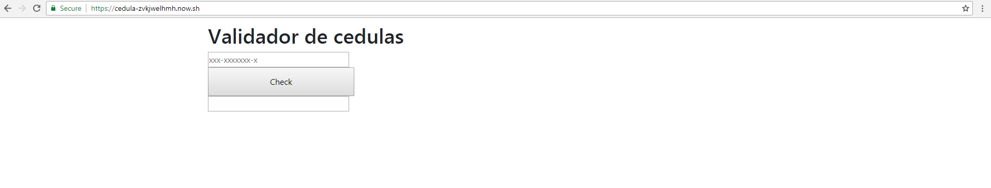

<html><head>

<link rel="stylesheet" type="text/css" class="__meteor-css__" href="/f39c9c7aefc88db83c522e8d1ba1e243250c905b.css?meteor_css_resource=true">

<title>cedula</title>

<link rel="stylesheet" href="https://stackpath.bootstrapcdn.com/bootstrap/4.1.3/css/bootstrap.min.css" integrity="sha384-MCw98/SFnGE8fJT3GXwEOngsV7Zt27NXFoaoApmYm81iuXoPkFOJwJ8ERdknLPMO" crossorigin="anonymous">

</head>

<body>

<script type="text/javascript">__meteor_runtime_config__ = JSON.parse(decodeURIComponent("%7B%22meteorRelease%22%3A%22METEOR%401.7.0.5%22%2C%22meteorEnv%22%3A%7B%22NODE_ENV%22%3A%22production%22%2C%22TEST_METADATA%22%3A%22%7B%7D%22%7D%2C%22PUBLIC_SETTINGS%22%3A%7B%7D%2C%22ROOT_URL%22%3A%22http%3A%2F%2Flocalhost%3A3000%22%2C%22ROOT_URL_PATH_PREFIX%22%3A%22%22%2C%22appId%22%3A%22dam5e9pbe2nm.ncqht634a0o%22%2C%22autoupdateVersion%22%3A%225616c8edb2c7386ead9880b23c0ab5144c952420%22%2C%22autoupdateVersionRefreshable%22%3A%22178fb1ea88f10b12c349811fa3410ab8492cf8a4%22%2C%22autoupdateVersionCordova%22%3A%22none%22%2C%22isModern%22%3Atrue%7D"))</script>

<script type="text/javascript" src="/c6248020346ec40b3c9391c86914c0c3b5709b1f.js?meteor_js_resource=true"></script>

<style>

background: linear-gradient(218deg, #246655, #366624, #6da4d9, #f39681);

background-size: 800% 800%;

-webkit-animation: AnimationName 3s ease infinite;

-moz-animation: AnimationName 3s ease infinite;

animation: AnimationName 3s ease infinite;

@-webkit-keyframes AnimationName {

0%{background-position:0% 50%}

50%{background-position:100% 50%}

100%{background-position:0% 50%}

}

@-moz-keyframes AnimationName {

0%{background-position:0% 50%}

50%{background-position:100% 50%}

100%{background-position:0% 50%}

}

@keyframes AnimationName {

0%{background-position:0% 50%}

50%{background-position:100% 50%}

100%{background-position:0% 50%}

}</style>

<div class="container" style="width:100%; height:100%; margin:0 auto;">

<h1 style=" justify-content: center;"> Validador de cedulas</h1>

<input style="display: inline-block;" type="text" id="cedulaNumber" placeholder="xxx-xxxxxxx-x" size="35"><br>

<button style="padding: 14px 118px; justify-content: center;text-align: center;" type="button" id="checker" value="Check">Check</button><br>

<input style=" justify-content: center;text-align: center;" type="text" id="resultado" size="35" readonly="">

</div></body></html>

Practica 4

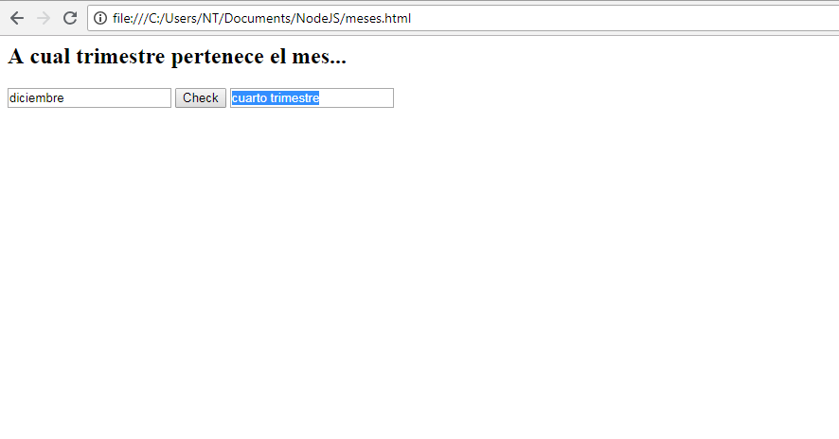

<head>

</head>

<body>

<h2>A cual trimestre pertenece el mes...</h2>

<input id="month" type="text" placeholder="Mes">

<Button onclick="CheckMes()" >Check</Button>

<input type="text" readonly id="result">

</body>

<script>

function CheckMes()

{

var mes = document.getElementById("month").value;

mes = mes.toUpperCase();

if(mes=="ENERO"||mes=="FEBRERO"||mes=="MARZO"? document.getElementById("result").value="primer trimestre":mes=="ABRIL"||mes=="MAYO"||mes=="JUNIO"? document.getElementById("result").value="segundo trimestre":mes=="JULIO"||mes=="AGOSTO"||mes=="SEPTIEMBRE"? document.getElementById("result").value="tercer trimestre":mes=="OCTUBRE"||mes=="NOVIEMBRE"||mes=="DICIEMBRE"? document.getElementById("result").value="cuarto trimestre":document.getElementById("result").value="No es un mes" )

{

}

}

</script>

Practica 5

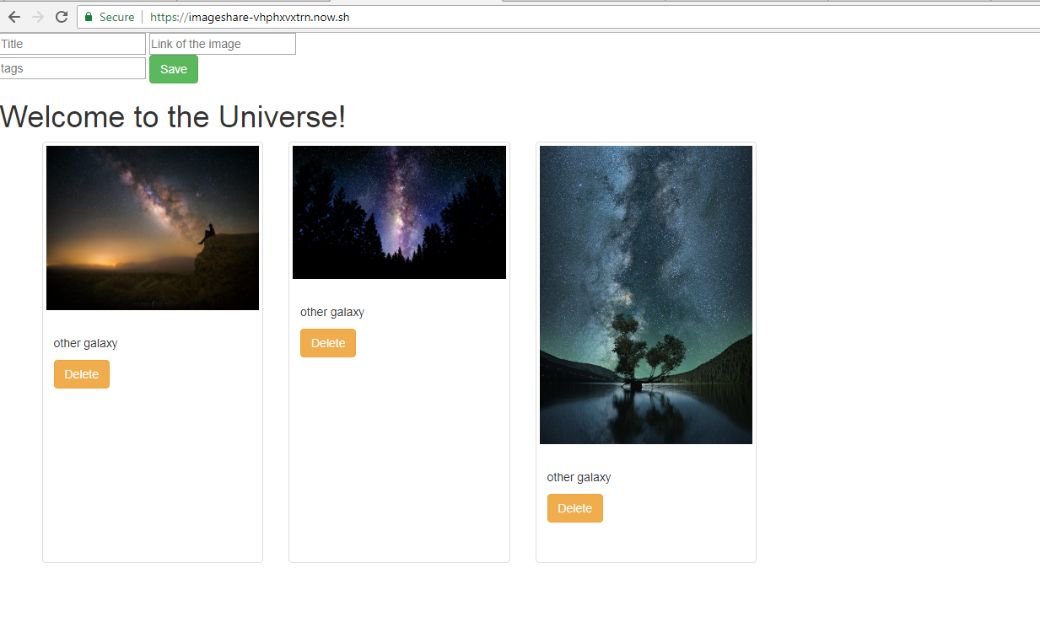

<html><head>

<link rel="stylesheet" type="text/css" class="__meteor-css__" href="/6e2c14a6ff7929900673657345c5b56e98e0226e.css?meteor_css_resource=true">

<title>Image collection</title>

</head>

<body>

<script type="text/javascript">__meteor_runtime_config__ = JSON.parse(decodeURIComponent("%7B%22meteorRelease%22%3A%22METEOR%401.7.0.5%22%2C%22meteorEnv%22%3A%7B%22NODE_ENV%22%3A%22production%22%2C%22TEST_METADATA%22%3A%22%7B%7D%22%7D%2C%22PUBLIC_SETTINGS%22%3A%7B%7D%2C%22ROOT_URL%22%3A%22http%3A%2F%2Flocalhost%3A3000%22%2C%22ROOT_URL_PATH_PREFIX%22%3A%22%22%2C%22appId%22%3A%22d74ooymp2g3.xnwjn2ipi9ue%22%2C%22autoupdateVersion%22%3A%224a6e57952c8936ed6c3f07c7c10ff3c25307ae6c%22%2C%22autoupdateVersionRefreshable%22%3A%22498199e882e6f7221b8202c750fa2b0943829041%22%2C%22autoupdateVersionCordova%22%3A%22none%22%2C%22isModern%22%3Atrue%7D"))</script>

<script type="text/javascript" src="/2cb26b5bcfb9ede2942c155d68beab326c347272.js?meteor_js_resource=true"></script>

<input type="text" placeholder="Title" id="image_title" class="image_title">

<input type="text" placeholder="Link of the image" id="image_src" class="image_src">

<br><input type="text" placeholder="tags" id="image_alt" class="image_alt">

<input type="button" class="btn btn-success" value="Save" id="save">

<h1>Welcome to the Universe!</h1>

<div class="container">

<div class="row">

<div class="col-xs-12 col-md-3" id="EoTudAEShXpL5ZKLf">

<div class="thumbnail">

<img class="js-image" src="galaxy1.jpg" alt="other galaxy">

<div class="caption">

<h3></h3>

<p>other galaxy</p>

<button class="js-del-image btn btn-warning">Delete</button>

</div>

</div>

</div>

<div class="col-xs-12 col-md-3" id="gaPToewYwwbPuajc5">

<div class="thumbnail">

<img class="js-image" src="galaxy2.jpg" alt="other galaxy">

<div class="caption">

<h3></h3>

<p>other galaxy</p>

<button class="js-del-image btn btn-warning">Delete</button>

</div>

</div>

</div>

<div class="col-xs-12 col-md-3" id="DY6iMCqLoojdTXdX6">

<div class="thumbnail">

<img class="js-image" src="galaxy3.jpg" alt="other galaxy">

<div class="caption">

<h3></h3>

<p>other galaxy</p>

<button class="js-del-image btn btn-warning">Delete</button>

</div>

</div>

</div>

</div>

</div></body></html>

Practica 6

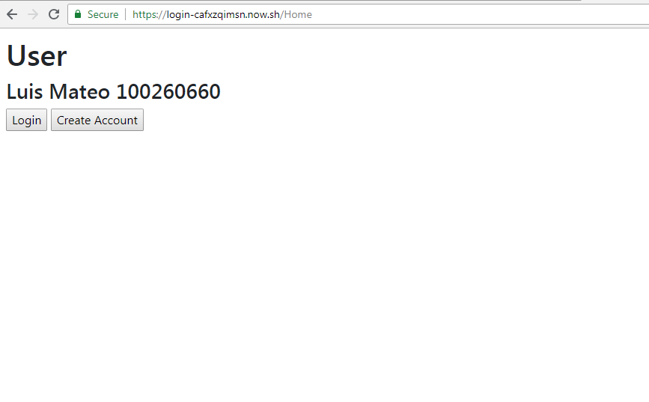

<html><head>

<link rel="stylesheet" type="text/css" class="__meteor-css__" href="/f39c9c7aefc88db83c522e8d1ba1e243250c905b.css?meteor_css_resource=true">

<title>Login</title>

<link rel="stylesheet" href="https://stackpath.bootstrapcdn.com/bootstrap/4.1.3/css/bootstrap.min.css" integrity="sha384-MCw98/SFnGE8fJT3GXwEOngsV7Zt27NXFoaoApmYm81iuXoPkFOJwJ8ERdknLPMO" crossorigin="anonymous">

</head>

<body>

<script type="text/javascript">__meteor_runtime_config__ = JSON.parse(decodeURIComponent("%7B%22meteorRelease%22%3A%22METEOR%401.7.0.5%22%2C%22meteorEnv%22%3A%7B%22NODE_ENV%22%3A%22production%22%2C%22TEST_METADATA%22%3A%22%7B%7D%22%7D%2C%22PUBLIC_SETTINGS%22%3A%7B%7D%2C%22ROOT_URL%22%3A%22http%3A%2F%2Flocalhost%3A3000%22%2C%22ROOT_URL_PATH_PREFIX%22%3A%22%22%2C%22appId%22%3A%22sr3xyfn1v3fe.er114z86mmn%22%2C%22autoupdateVersion%22%3A%2230b1524ba468dfef66493b2bed876d94d254a31c%22%2C%22autoupdateVersionRefreshable%22%3A%227688ad5cd1d1cd746e2ba8ff0fde0a3fae3fec49%22%2C%22autoupdateVersionCordova%22%3A%22none%22%2C%22isModern%22%3Atrue%7D"))</script>

<script type="text/javascript" src="/cd09b1c270df6a02b51ee53148873780fc58c9a2.js?meteor_js_resource=true"></script>

<h1>User</h1>

<h3>Luis Mateo 100260660</h3>

<input id="LoginBtn" type="button" value="Login">

<input id="CreateBtn" type="button" value="Create Account"></body></html>

Practica 8

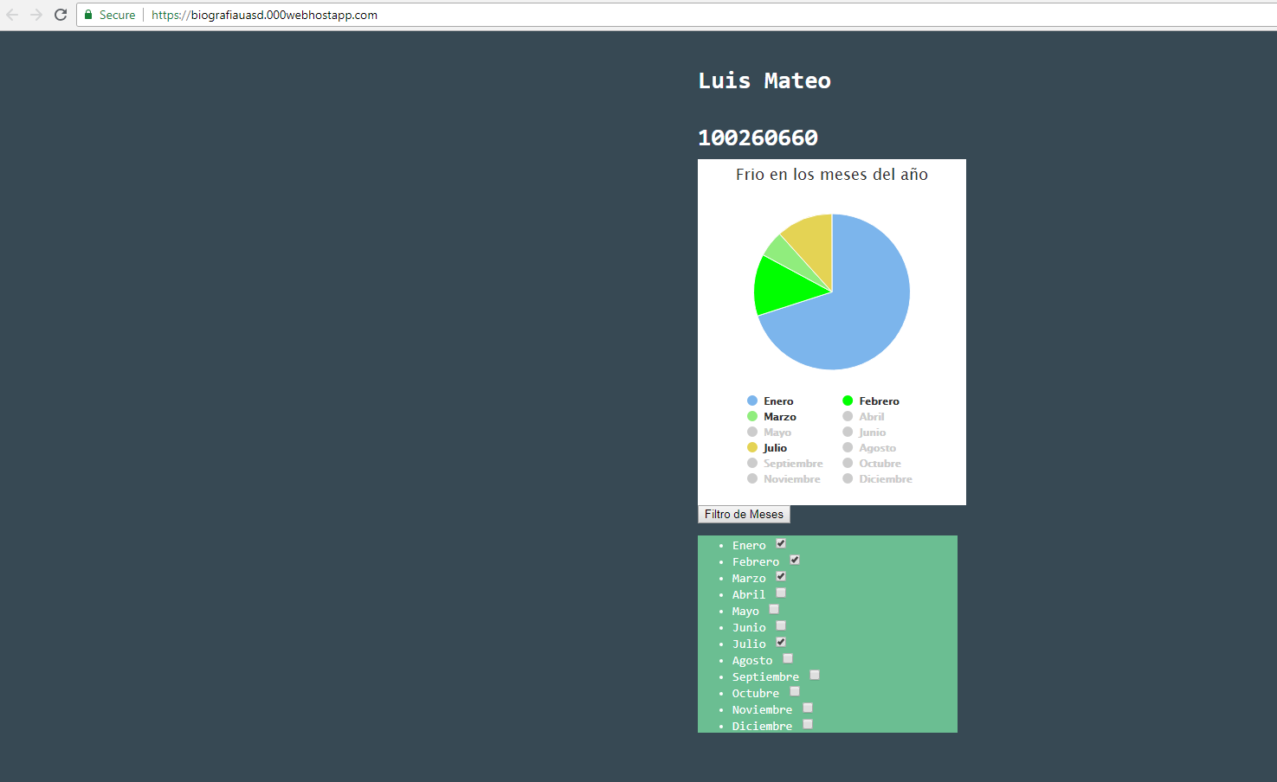

<head>

<script src="https://code.jquery.com/jquery-3.1.1.min.js"></script>

<script src="https://code.highcharts.com/highcharts.js"></script>

<script src="https://code.highcharts.com/modules/exporting.js"></script>

<script src="https://code.highcharts.com/modules/export-data.js"></script>

<script src="https://ajax.googleapis.com/ajax/libs/jquery/3.3.1/jquery.min.js"></script>

<!-- jQuery library -->

<script src="https://ajax.googleapis.com/ajax/libs/jquery/3.3.1/jquery.min.js"></script>

<!-- MultiSelect CSS & JS library -->

<link href="multiselect/jquery.multiselect.css" rel="stylesheet" />

<script src="multiselect/jquery.multiselect.js"></script>

</head>

<body>

<style>

body {

font: normal 14px/100% "Andale Mono", AndaleMono, monospace;

color: #fff;

padding: 50px;

width: 300px;

margin: 0 auto;

background-color: #374954;

}

.dropdown {

position: absolute;

top:50%;

transform: translateY(-50%);

}

a {

color: #fff;

}

.dropdown dd,

.dropdown dt {

margin: 0px;

padding: 0px;

}

.dropdown ul {

margin: -1px 0 0 0;

}

.dropdown dd {

position: relative;

}

.dropdown a,

.dropdown a:visited {

color: #fff;

text-decoration: none;

outline: none;

font-size: 12px;

}

.dropdown dt a {

background-color: #4F6877;

display: block;

padding: 8px 20px 5px 10px;

min-height: 25px;

line-height: 24px;

overflow: hidden;

border: 0;

width: 272px;

}

.dropdown dt a span,

.multiSel span {

cursor: pointer;

display: inline-block;

padding: 0 3px 2px 0;

}

.dropdown dd ul {

background-color: #4F6877;

border: 0;

color: #fff;

display: none;

left: 0px;

padding: 2px 15px 2px 5px;

position: absolute;

top: 2px;

width: 280px;

list-style: none;

height: 100px;

overflow: auto;

}

.dropdown span.value {

display: none;

}

.dropdown dd ul li a {

padding: 5px;

display: block;

}

.dropdown dd ul li a:hover {

background-color: #fff;

}

button {

background-color: #6BBE92;

width: 302px;

border: 0;

padding: 10px 0;

margin: 5px 0;

text-align: center;

color: #fff;

font-weight: bold;

}

.target{

background-color: #6BBE92;

}

</style>

<h1>Luis Mateo</h1> <br><h1>100260660</h1>

<div id="container" style="min-width: 310px; height: 400px; max-width: 600px; margin: 0 auto"></div>

<input type="button"

id="secondaryButton"

value="Filtro de Meses"/>

<div class="target">

<ul>

<li><label>Enero</label> <input type="checkbox" onclick="$( '.highcharts-color-0:eq(3)' ).trigger( 'click' );"> </li>

<li><label>Febrero</label> <input type="checkbox" onclick="$( '.highcharts-color-1:eq(2)' ).trigger( 'click');"></li>

<li><label>Marzo</label> <input type="checkbox" onclick="$( '.highcharts-color-2:eq(1)' ).trigger( 'click' );"> </li>

<li><label>Abril</label> <input type="checkbox" onclick="$( '.highcharts-color-3:eq(1)' ).trigger( 'click' );" ></li>

<li><label>Mayo</label> <input type="checkbox" onclick="$( '.highcharts-color-4:eq(1)' ).trigger( 'click' );"> </li>

<li><label>Junio</label> <input type="checkbox" onclick="$( '.highcharts-color-5:eq(1)' ).trigger( 'click' );"> </li>

<li><label>Julio</label> <input type="checkbox" onclick="$( '.highcharts-color-6:eq(1)' ).trigger( 'click' );"></li>

<li><label>Agosto</label> <input type="checkbox" onclick="$( '.highcharts-color-7:eq(1)' ).trigger( 'click' );"></li>

<li><label>Septiembre</label> <input type="checkbox" onclick="$( '.highcharts-color-8:eq(1)' ).trigger( 'click' );"></li>

<li><label>Octubre</label> <input type="checkbox" onclick="$( '.highcharts-color-9:eq(1)' ).trigger( 'click' );"></li>

<li><label>Noviembre</label> <input type="checkbox" onclick="$( '.highcharts-color-0:eq(2)' ).trigger( 'click' );"></li>

<li><label>Diciembre</label> <input type="checkbox" onclick="$( '.highcharts-color-1:eq(3)' ).trigger( 'click' );"></li>

</ul>

</div>

</body>

<script>

// Build the chart

Highcharts.chart('container', {

chart: {

plotBackgroundColor: null,

plotBorderWidth: null,

plotShadow: false,

type: 'pie'

},

title: {

text: 'Frio en los meses del año'

},

tooltip: {

pointFormat: '{series.name}: <b>{point.percentage:.1f}%</b>'

},

plotOptions: {

pie: {

allowPointSelect: true,

cursor: 'pointer',

dataLabels: {

enabled: false

},

showInLegend: true

}

},

series: [{

name: 'Brands',

colorByPoint: true,

data: [ {

name: 'Enero',

y: 60

}, {

name: 'Febrero',

y: 11,

color:'#00ff00'

}, {

name: 'Marzo',

y: 4.67,

}, {

name: 'Abril',

y: 6

}, {

name: 'Mayo',

y: 6

}

, {

name: 'Junio',

y: 10

}

, {

name: 'Julio',

y: 10

}

, {

name: 'Agosto',

y:20

}, {

name: 'Septiembre',

y: 35

}, {

name: 'Octubre',

y: 14

}, {

name: 'Noviembre',

y: 50,

color:' #ff66b3'

},{

name: 'Diciembre',

y: 60,

sliced: true,

selected: true

}]

}]

});

</script>

<script>

$("#secondaryButton").on("click", () => {

$( ".target" ).toggle();

});

$( ".target" ).toggle();

$( '.highcharts-color-0:eq(3)' ).trigger( 'click' );

$( '.highcharts-color-1:eq(2)' ).trigger( 'click');

$( '.highcharts-color-2:eq(1)' ).trigger( 'click' );

$( '.highcharts-color-3:eq(1)' ).trigger( 'click' );

$( '.highcharts-color-4:eq(1)' ).trigger( 'click' );

$( '.highcharts-color-5:eq(1)' ).trigger( 'click' );

$( '.highcharts-color-6:eq(1)' ).trigger( 'click' );

$( '.highcharts-color-7:eq(1)' ).trigger( 'click' );

$( '.highcharts-color-8:eq(1)' ).trigger( 'click' );

$( '.highcharts-color-9:eq(1)' ).trigger( 'click' );

$( '.highcharts-color-0:eq(2)' ).trigger( 'click' );

$( '.highcharts-color-1:eq(3)' ).trigger( 'click' );

$(".highcharts-contextbutton").hide();

$(".highcharts-credits").hide();

</script>

Practica 9

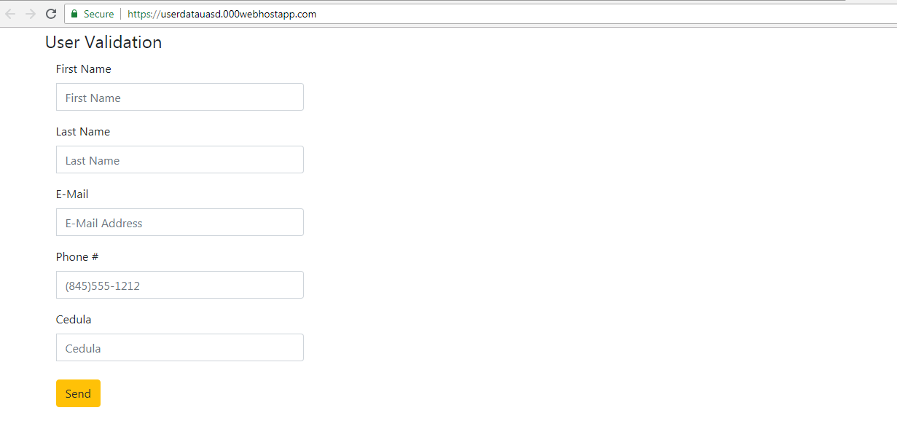

<html><head>

<script src="https://ajax.googleapis.com/ajax/libs/jquery/3.3.1/jquery.min.js"></script>

<script src="https://cdnjs.cloudflare.com/ajax/libs/bootstrap-validator/0.5.3/js/bootstrapValidator.js"></script>

<link rel="stylesheet" href="https://stackpath.bootstrapcdn.com/bootstrap/4.1.3/css/bootstrap.min.css" integrity="sha384-MCw98/SFnGE8fJT3GXwEOngsV7Zt27NXFoaoApmYm81iuXoPkFOJwJ8ERdknLPMO" crossorigin="anonymous">

</head>

<body>

<div class="container">

<form class="well form-horizontal bv-form" action=" " method="post" id="contact_form" novalidate="novalidate"><button type="submit" class="bv-hidden-submit" style="display: none; width: 0px; height: 0px;"></button>

<fieldset>

<legend>User Validation</legend>

<div class="form-group has-feedback">

<label class="col-md-4 control-label">First Name</label>

<div class="col-md-4 inputGroupContainer">

<div class="input-group">

<span class="input-group-addon"><i class="glyphicon glyphicon-user"></i></span>

<input name="first_name" placeholder="First Name" class="form-control" type="text" data-bv-field="first_name">

</div><i class="form-control-feedback bv-icon-input-group" data-bv-icon-for="first_name" style="display: none;"></i>

<small class="help-block" data-bv-validator="stringLength" data-bv-for="first_name" data-bv-result="NOT_VALIDATED" style="display: none;">Please enter a value with valid length</small><small class="help-block" data-bv-validator="notEmpty" data-bv-for="first_name" data-bv-result="NOT_VALIDATED" style="display: none;">Please supply your first name</small></div>

</div>

<div class="form-group has-feedback">

<label class="col-md-4 control-label">Last Name</label>

<div class="col-md-4 inputGroupContainer">

<div class="input-group">

<span class="input-group-addon"><i class="glyphicon glyphicon-user"></i></span>

<input name="last_name" placeholder="Last Name" class="form-control" type="text" data-bv-field="last_name">

</div><i class="form-control-feedback bv-icon-input-group" data-bv-icon-for="last_name" style="display: none;"></i>

<small class="help-block" data-bv-validator="stringLength" data-bv-for="last_name" data-bv-result="NOT_VALIDATED" style="display: none;">Please enter a value with valid length</small><small class="help-block" data-bv-validator="notEmpty" data-bv-for="last_name" data-bv-result="NOT_VALIDATED" style="display: none;">Please supply your last name</small></div>

</div>

<div class="form-group has-feedback">

<label class="col-md-4 control-label">E-Mail</label>

<div class="col-md-4 inputGroupContainer">

<div class="input-group">

<span class="input-group-addon"><i class="glyphicon glyphicon-envelope"></i></span>

<input name="email" placeholder="E-Mail Address" class="form-control" type="text" data-bv-field="email">

</div><i class="form-control-feedback bv-icon-input-group" data-bv-icon-for="email" style="display: none;"></i>

<small class="help-block" data-bv-validator="notEmpty" data-bv-for="email" data-bv-result="NOT_VALIDATED" style="display: none;">Please supply your email address</small><small class="help-block" data-bv-validator="emailAddress" data-bv-for="email" data-bv-result="NOT_VALIDATED" style="display: none;">Please supply a valid email address</small></div>

</div>

<div class="form-group has-feedback">

<label class="col-md-4 control-label">Phone #</label>

<div class="col-md-4 inputGroupContainer">

<div class="input-group">

<span class="input-group-addon"><i class="glyphicon glyphicon-earphone"></i></span>

<input name="phone" placeholder="(845)555-1212" class="form-control" type="text" data-bv-field="phone">

</div><i class="form-control-feedback bv-icon-input-group" data-bv-icon-for="phone" style="display: none;"></i>

<small class="help-block" data-bv-validator="notEmpty" data-bv-for="phone" data-bv-result="NOT_VALIDATED" style="display: none;">Please supply your phone number</small><small class="help-block" data-bv-validator="phone" data-bv-for="phone" data-bv-result="NOT_VALIDATED" style="display: none;">Please supply a vaild phone number </small></div>

</div>

<div class="form-group has-feedback">

<label class="col-md-4 control-label">Cedula</label>

<div class="col-md-4 inputGroupContainer">

<div class="input-group">

<span class="input-group-addon"><i class="glyphicon glyphicon-home"></i></span>

<input name="address" placeholder="Cedula" class="form-control" type="text" data-bv-field="address">

</div><i class="form-control-feedback bv-icon-input-group" data-bv-icon-for="address" style="display: none;"></i>

<small class="help-block" data-bv-validator="stringLength" data-bv-for="address" data-bv-result="NOT_VALIDATED" style="display: none;">Please enter at least 11 characters</small><small class="help-block" data-bv-validator="notEmpty" data-bv-for="address" data-bv-result="NOT_VALIDATED" style="display: none;">Please supply your Cedula</small></div>

</div>

<div class="alert alert-success" role="alert" id="success_message">Success <i class="glyphicon glyphicon-thumbs-up"></i> Message was sent</div>

<div class="form-group">

<label class="col-md-4 control-label"></label>

<div class="col-md-4">

<button type="submit" class="btn btn-warning">Send <span class="glyphicon glyphicon-send"></span></button>

</div>

</div>

</fieldset>

</form>

</div>

<script>

$(document).ready(function() {

$('#contact_form').bootstrapValidator({

feedbackIcons: {

valid: 'glyphicon glyphicon-ok',

invalid: 'glyphicon glyphicon-remove',

validating: 'glyphicon glyphicon-refresh'

},

fields: {

first_name: {

validators: {

stringLength: {

min: 2,

},

notEmpty: {

message: 'Please supply your first name'

}

}

},

last_name: {

validators: {

stringLength: {

min: 2,

},

notEmpty: {

message: 'Please supply your last name'

}

}

},

email: {

validators: {

notEmpty: {

message: 'Please supply your email address'

},

emailAddress: {

message: 'Please supply a valid email address'

}

}

},

phone: {

validators: {

notEmpty: {

message: 'Please supply your phone number'

},

phone: {

country: 'US',

message: 'Please supply a vaild phone number '

}

}

},

address: {

validators: {

stringLength: {

min: 11,

max: 11,

message:'Please enter at least 11 characters'

},

notEmpty: {

message: 'Please supply your Cedula'

}

}

},

city: {

validators: {

stringLength: {

min: 4,

},

notEmpty: {

message: 'Please supply your city'

}

}

},

state: {

validators: {

notEmpty: {

message: 'Please select your state'

}

}

},

zip: {

validators: {

notEmpty: {

message: 'Please supply your zip code'

},

zipCode: {

country: 'US',

message: 'Please supply a vaild zip code'

}

}

},

comment: {

validators: {

stringLength: {

min: 10,

max: 200,

message:'Please enter at least 10 characters'

},

notEmpty: {

message: 'Please supply a description of your project'

}

}

}

}

})

.on('success.form.bv', function(e) {

$('#success_message').slideDown({ opacity: "show" }, "slow") // Do something ...

$('#contact_form').data('bootstrapValidator').resetForm();

e.preventDefault();

var $form = $(e.target);

var bv = $form.data('bootstrapValidator');

$.post($form.attr('action'), $form.serialize(), function(result) {

console.log(result);

}, 'json');

});

});

</script>

<style>

#success_message{ display: none;}

</style>

<div style="text-align: right;position: fixed;z-index:9999999;bottom: 0; width: 100%;cursor: pointer;line-height: 0;display:block !important;"><a title="Hosted on free web hosting 000webhost.com. Host your own website for FREE." target="_blank" href="https://www.000webhost.com/?utm_source=000webhostapp&amp;utm_campaign=000_logo&amp;utm_medium=website_userdatauasd&amp;utm_content=footer_img"><img src="https://cdn.rawgit.com/000webhost/logo/e9bd13f7/footer-powered-by-000webhost-white2.png" alt="www.000webhost.com"></a></div></body></html>